*Assignment 4(Group Assignment)*

*Winter 2023*

*Instructor: Faisal Khan*

|  |  |  |
| --- | --- | --- |
| *Name* | *Student ID* | *Group#* |
| *Rajendra Prasad Dhakal* | *C0853186* |  |
| *Niku Thapa* | *C0842720* |  |
| *Anmol Gurung* | *C0842931* |  |
| *Mohammed Sohail Sajid* | *C0850557* |  |
| *Ghazaleh Dallal Esfahani* | *C0819544* |  |

1-Use Documentation Comments where needed and use Javadoc to create HTML files for documentation.

2-In your project src folder add this word document with all your group members names and paste the screen shots of your output after each question.

2-Right Click on your Project Folder in Eclipse, Copy Option is available. Create a copy of the Project and upload the zipped folder using Moodle.

Create a Rest API Resource named Book for an online Library.You should be able to perform all the Crud Operations using the URLS like Inserting Book ,display

All books ,show a specific book based on id,update and delete a Book .Your

Model Class Book may have fields like id , name ,author

,price , genre and publishing date .

Use Postman tool for testing this Rest API and test the URLs for method calls.

Creating a database with table Book . 10 marks

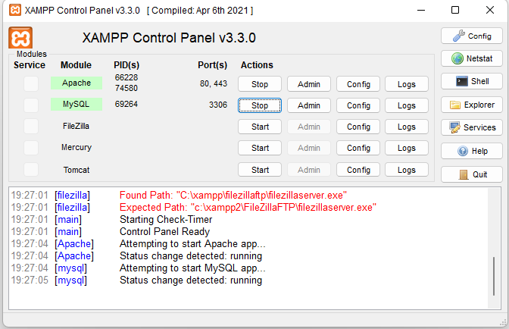

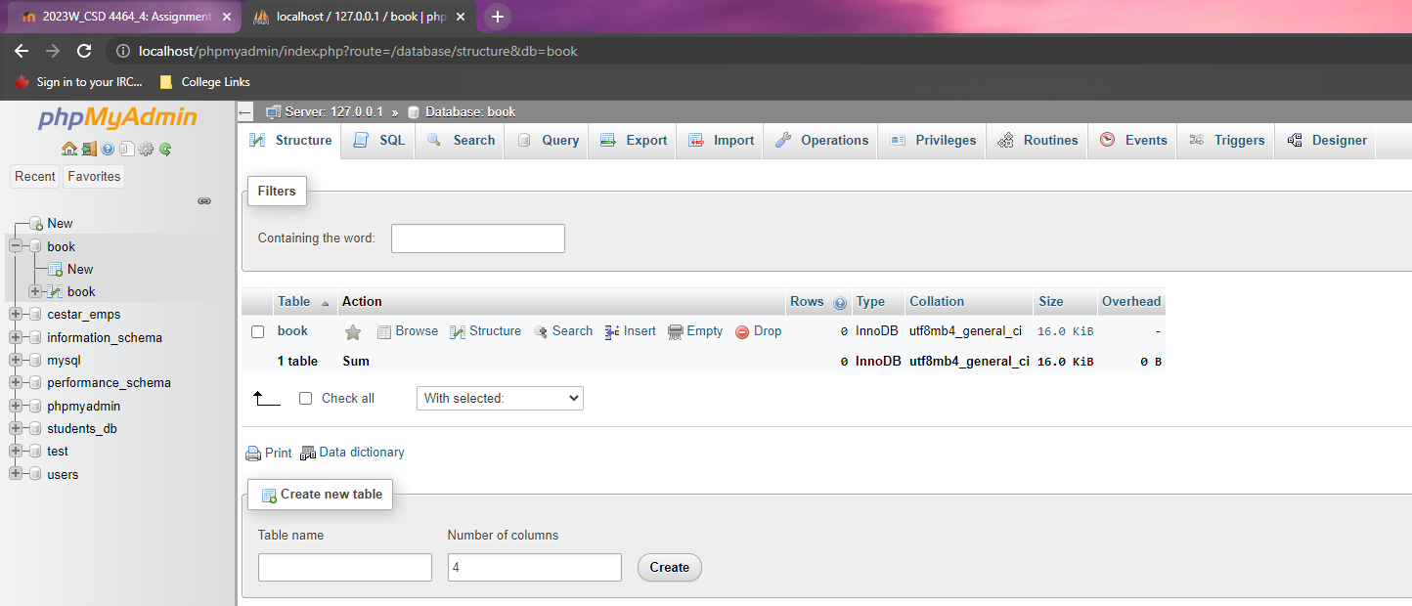

Creating Model Class Book . 10 marks

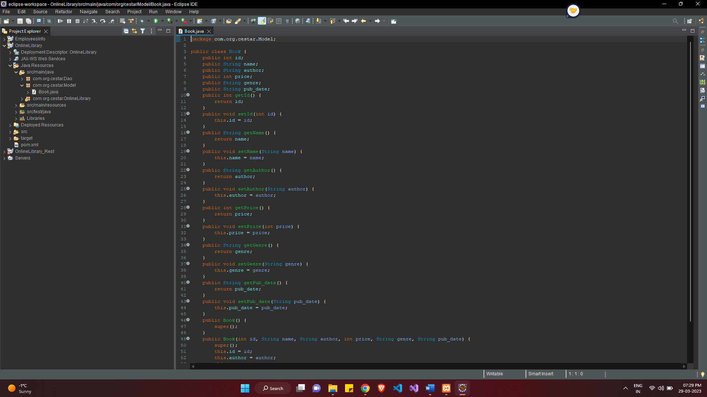

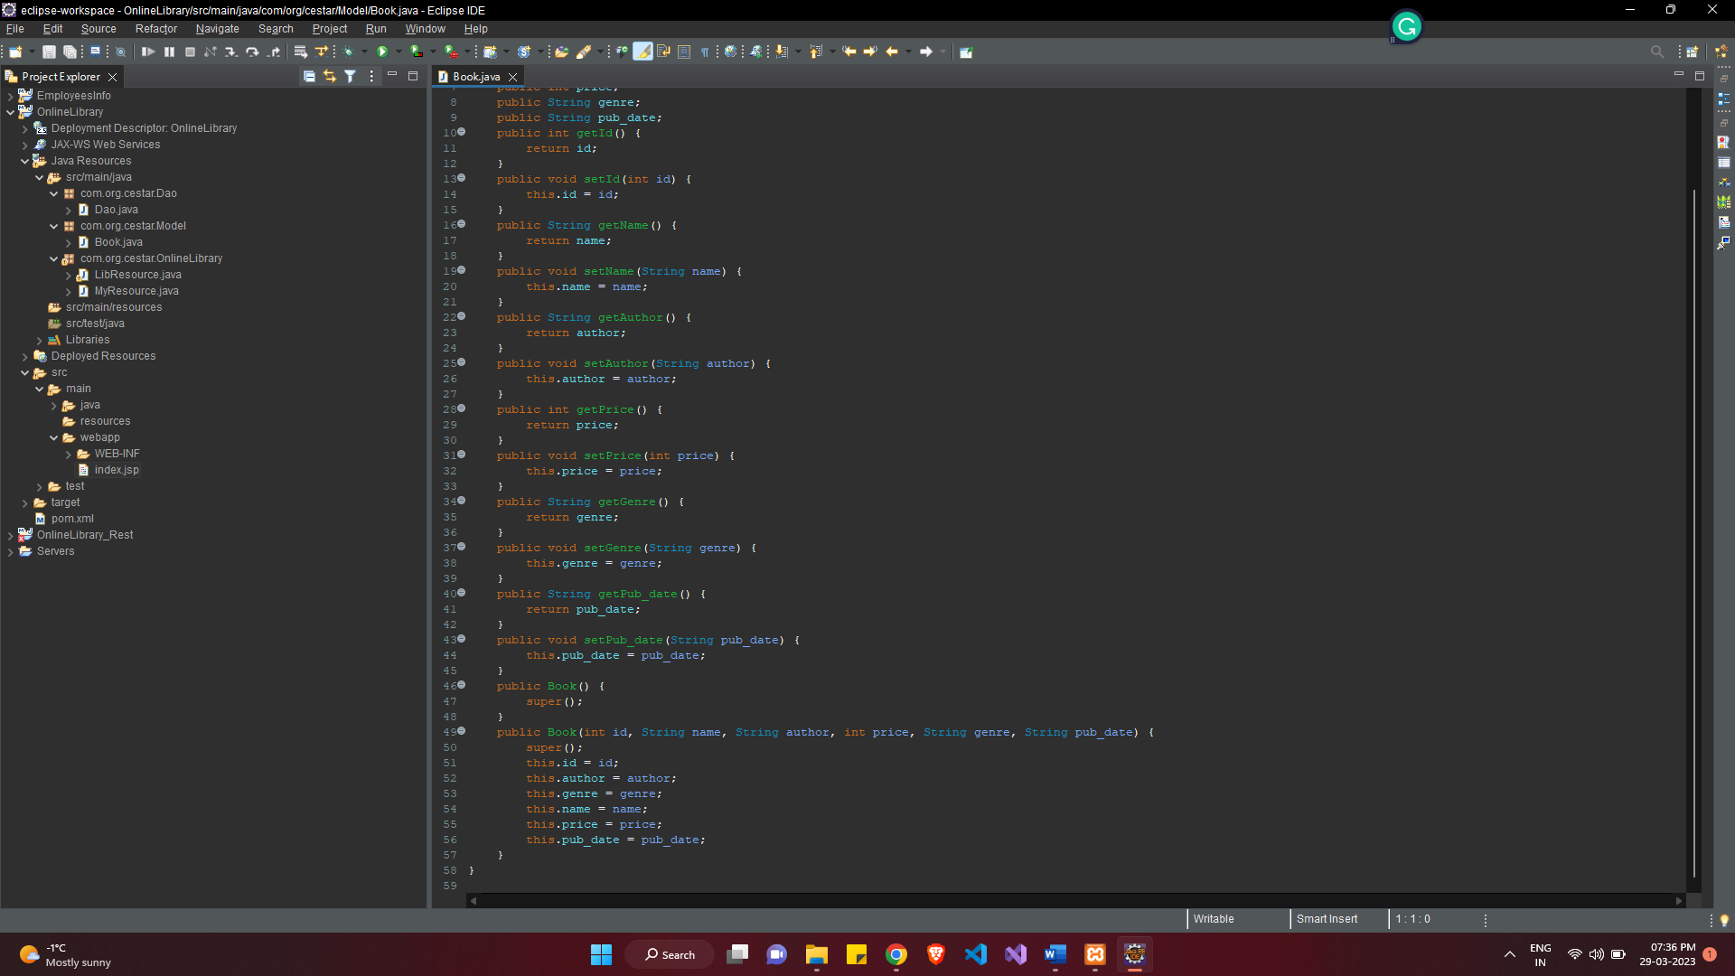

Creating dao class with all methods for Crud Operations. 30 marks

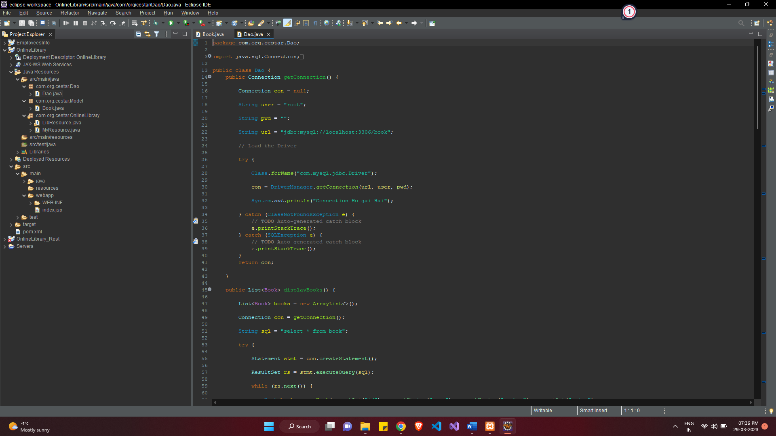

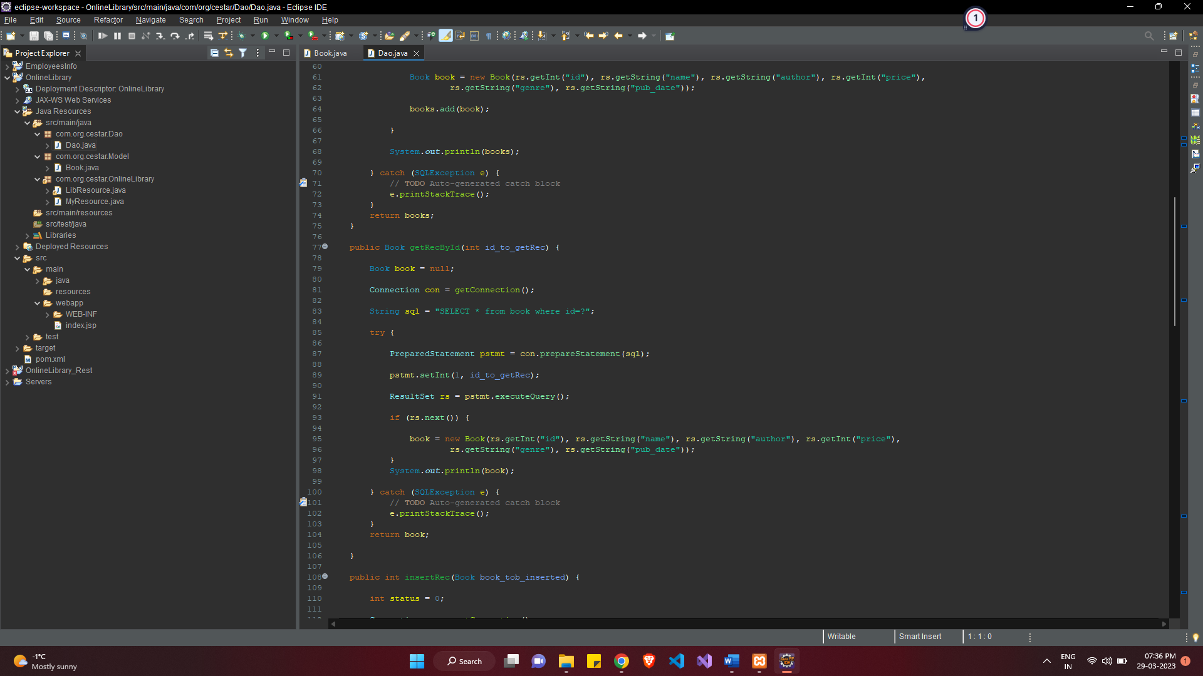

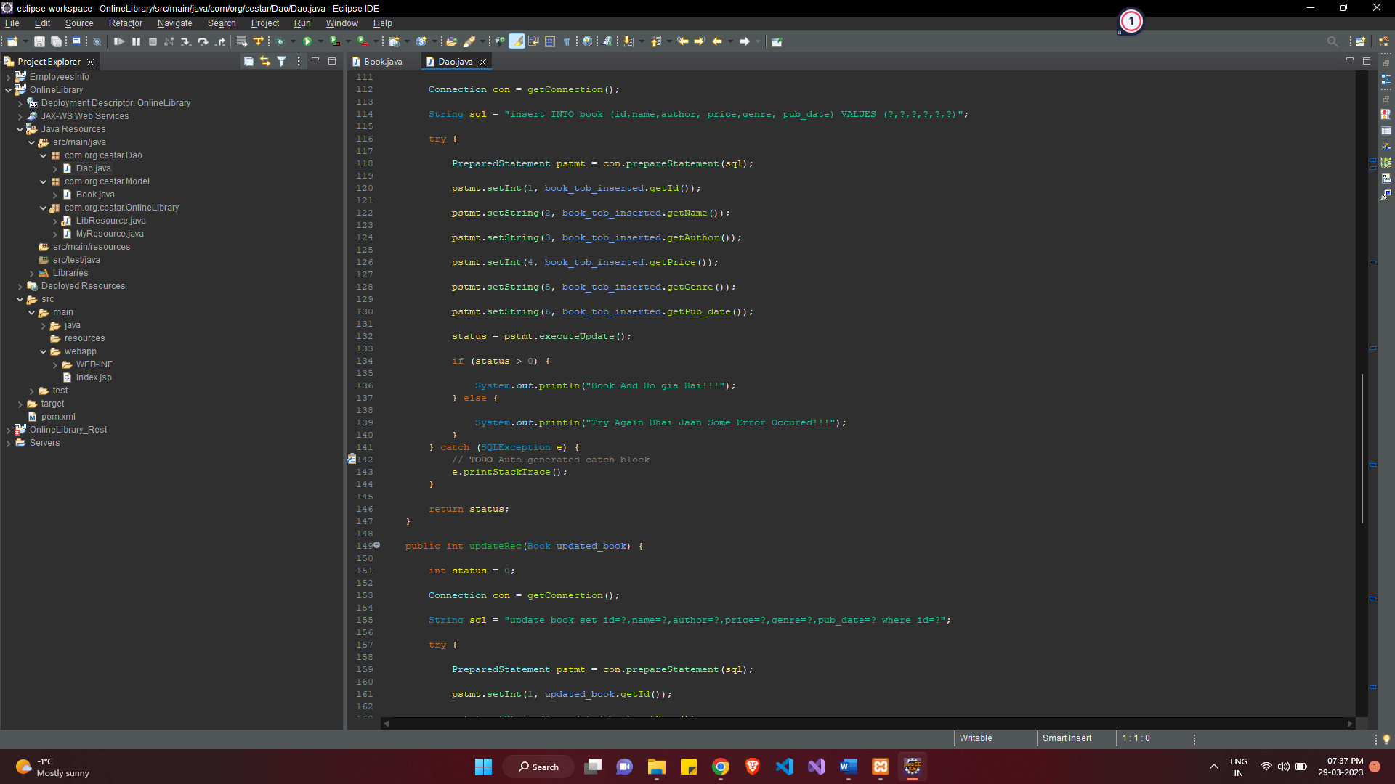

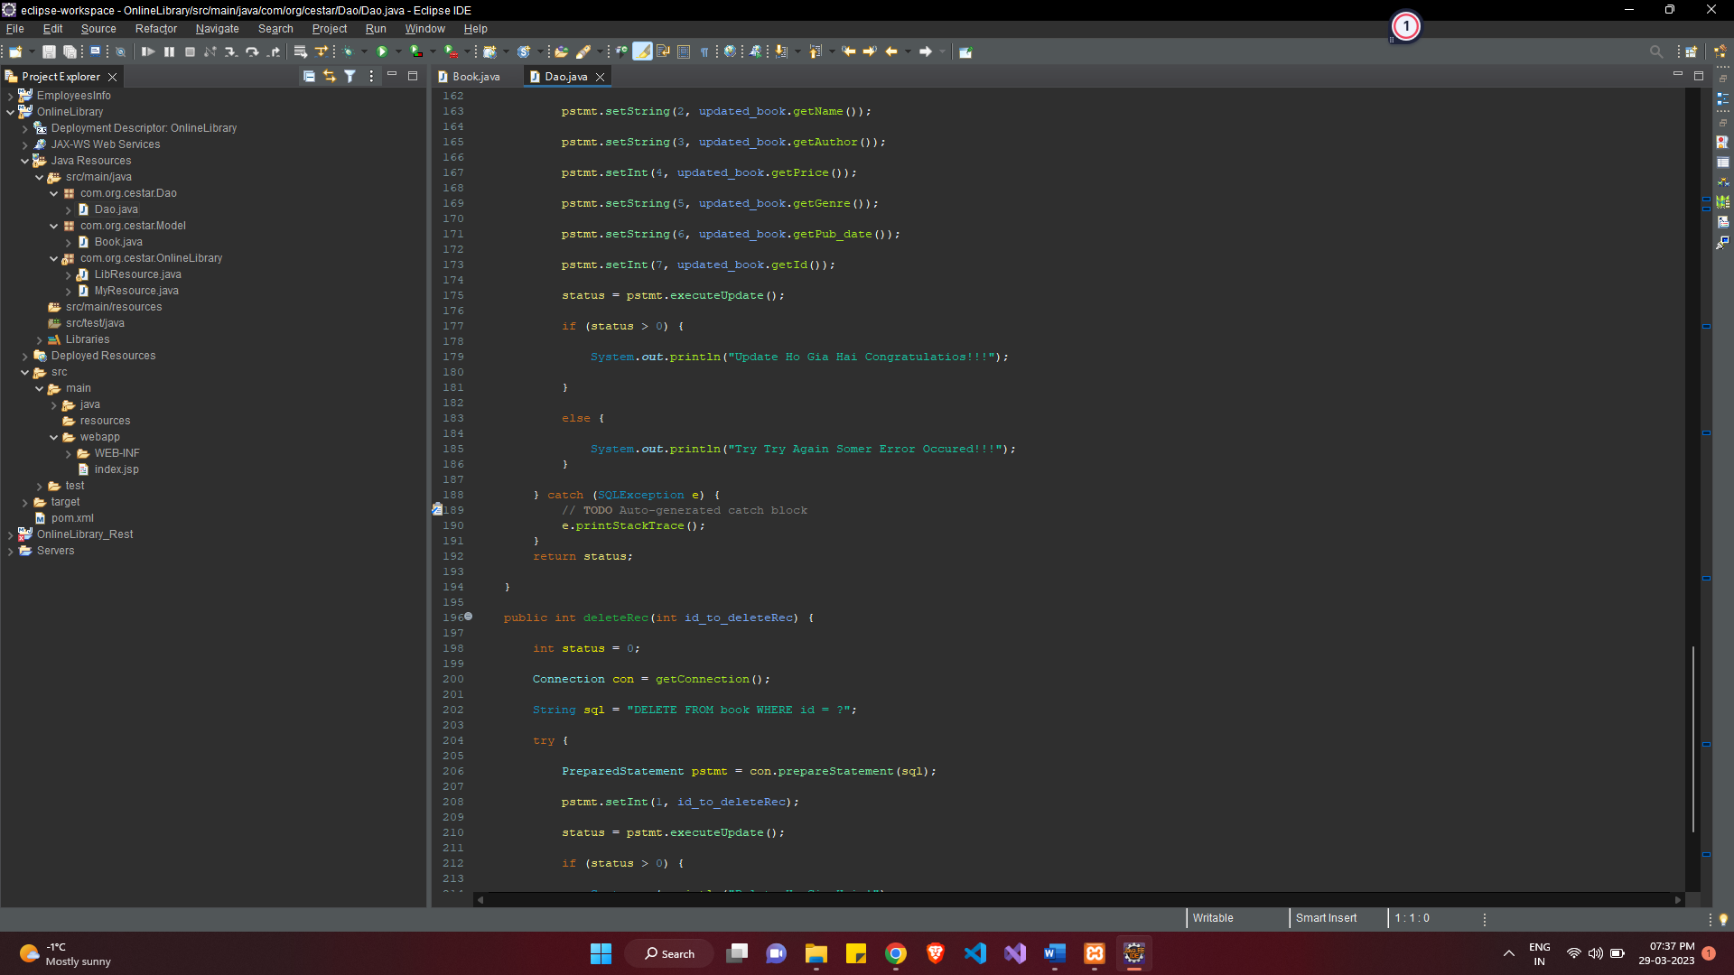

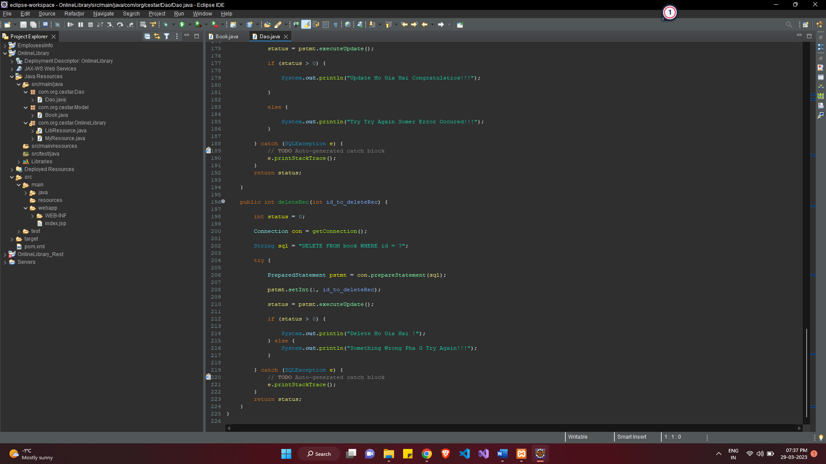

Creating a Resource class with all http methods . 20 marks

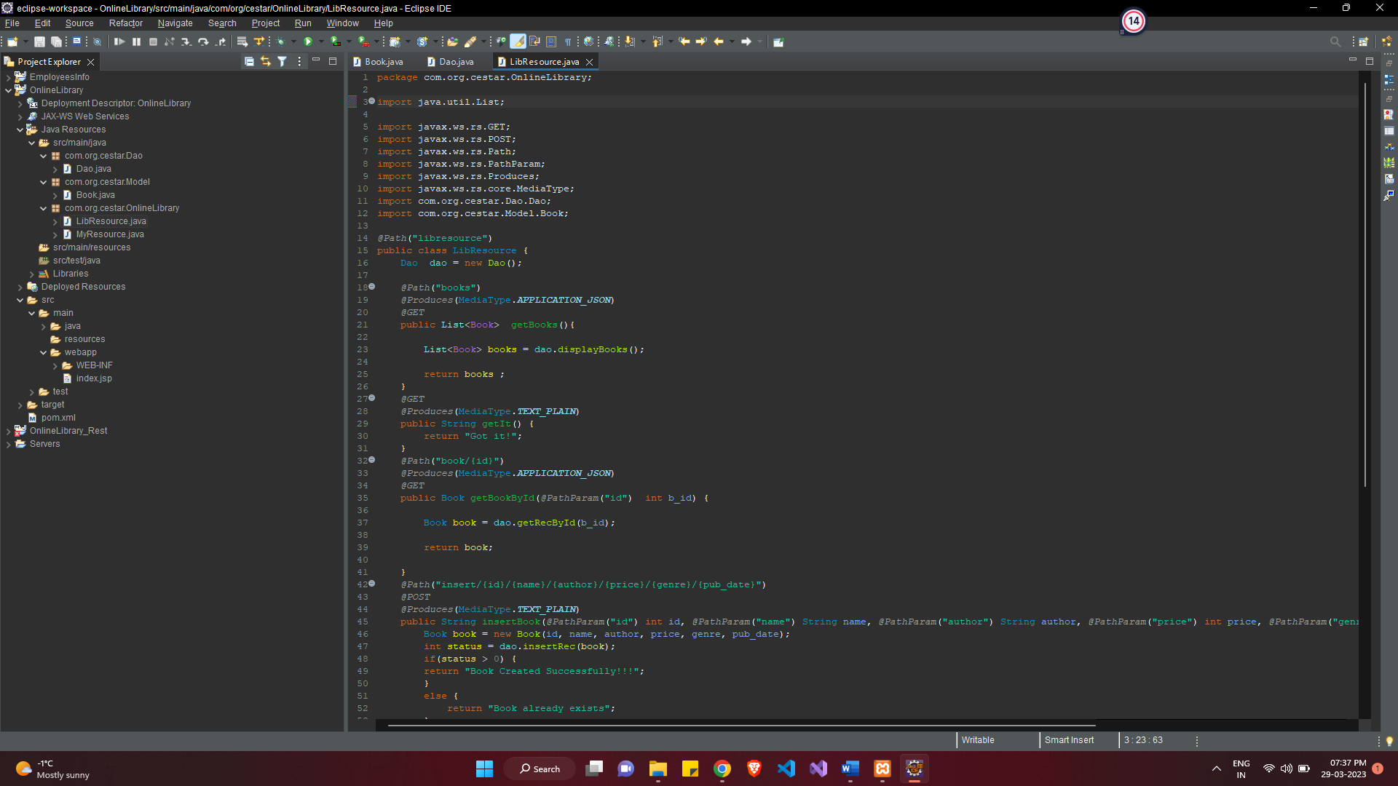

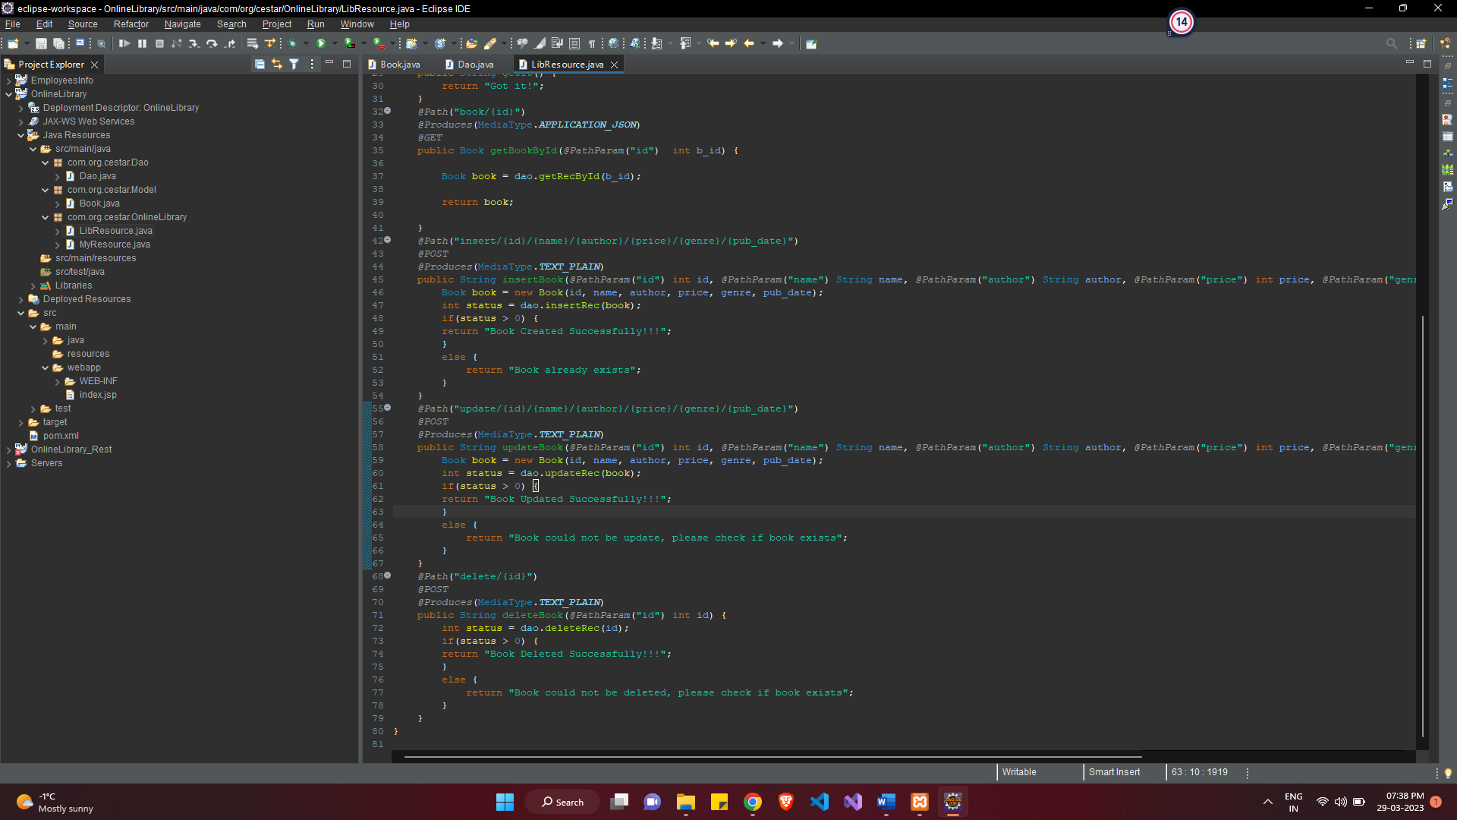

Showing proper response code using postman for each method. 30 marks

**Create Book HTTP Method:**

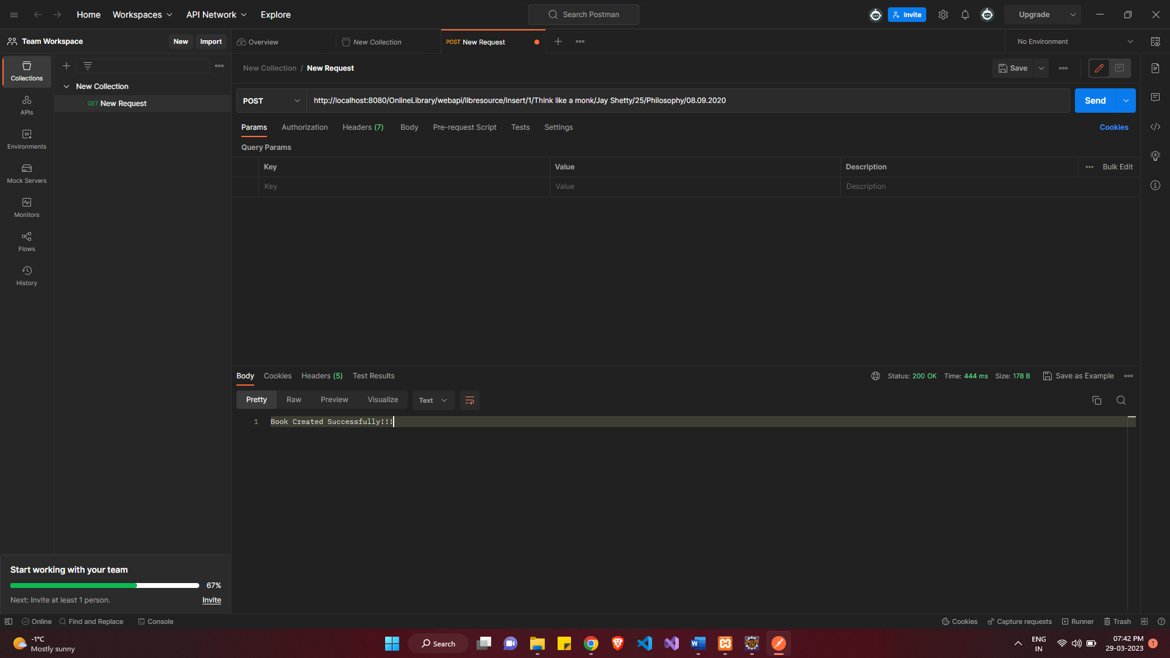

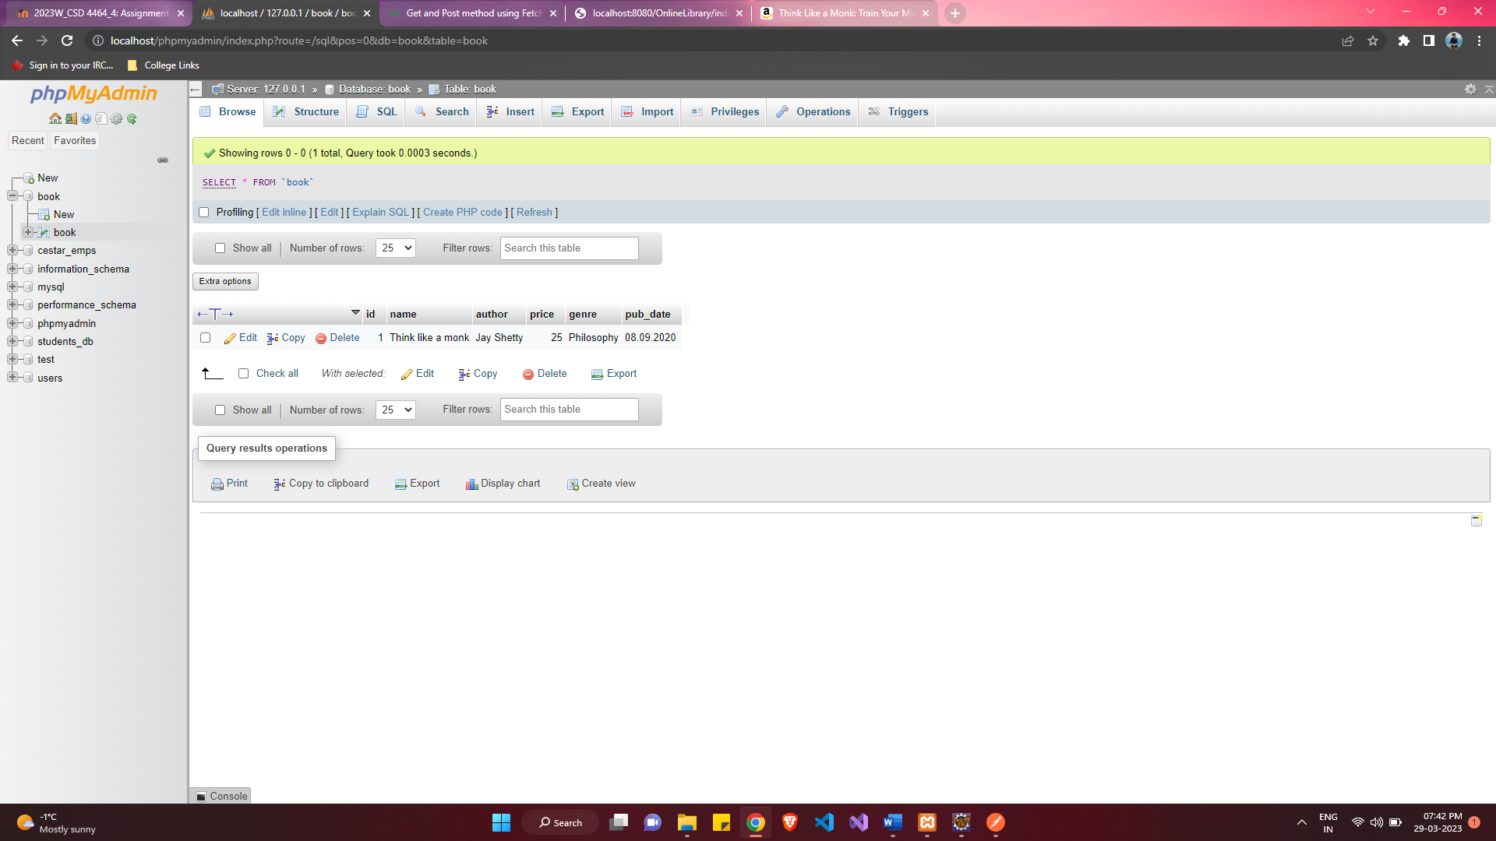

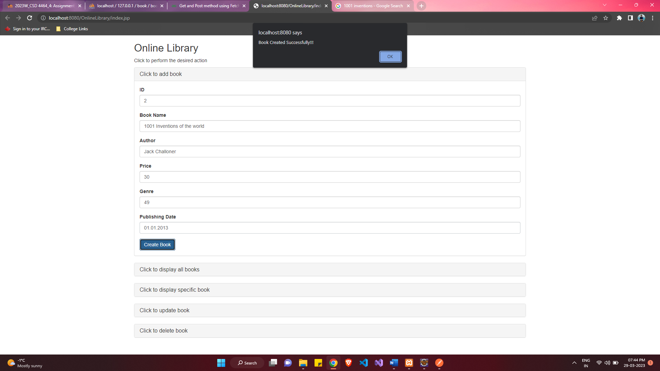

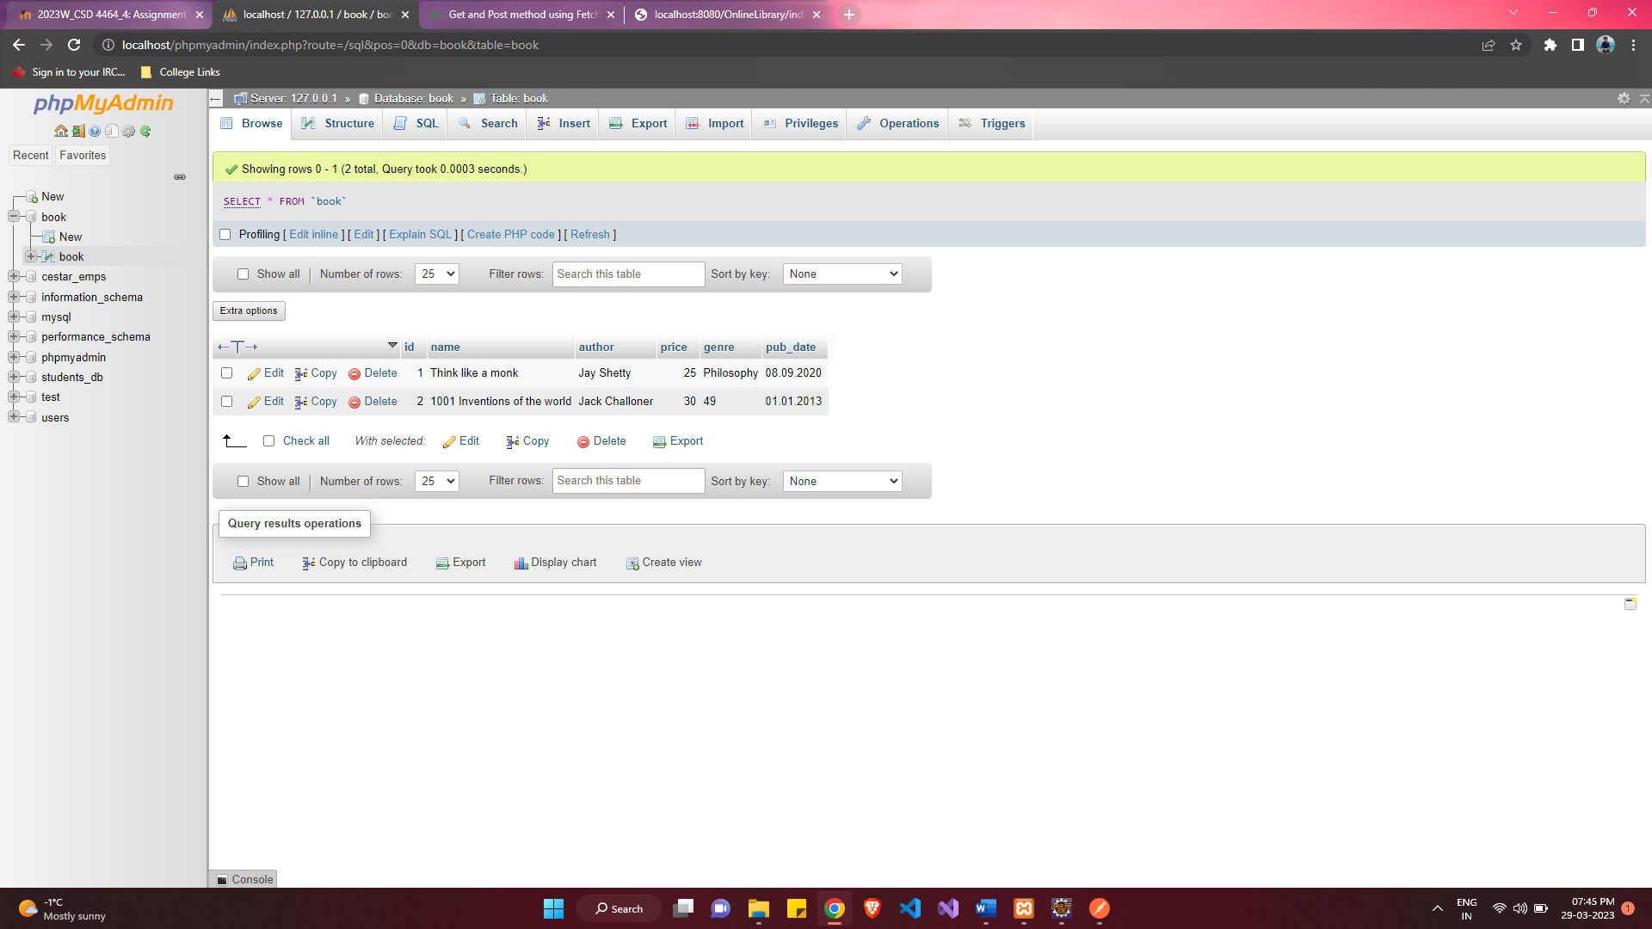

**Display All Books HTTP Method:**

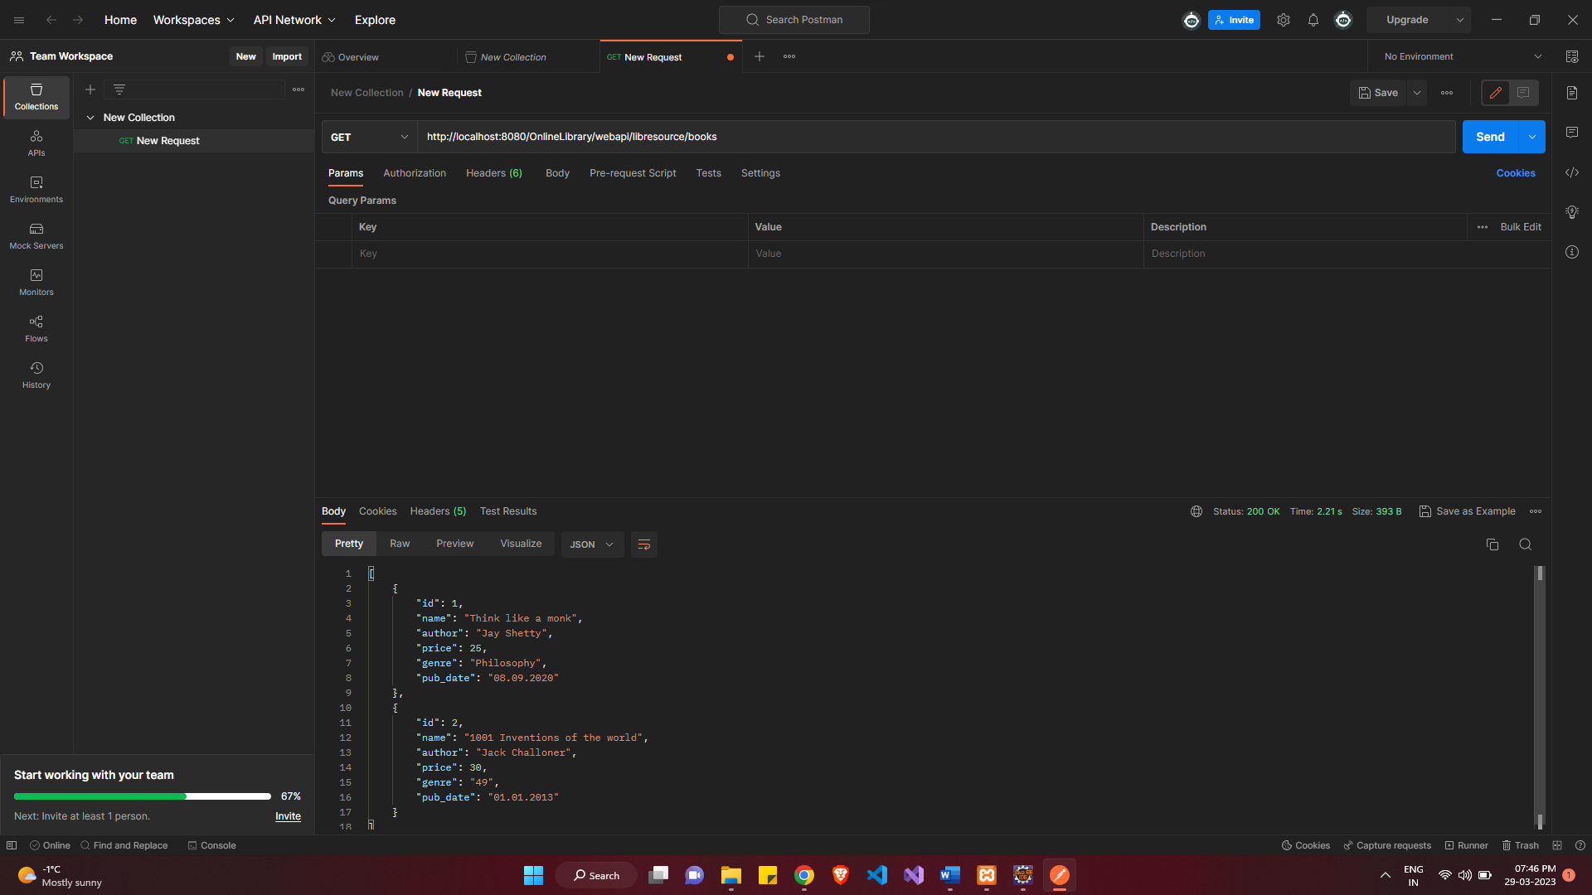

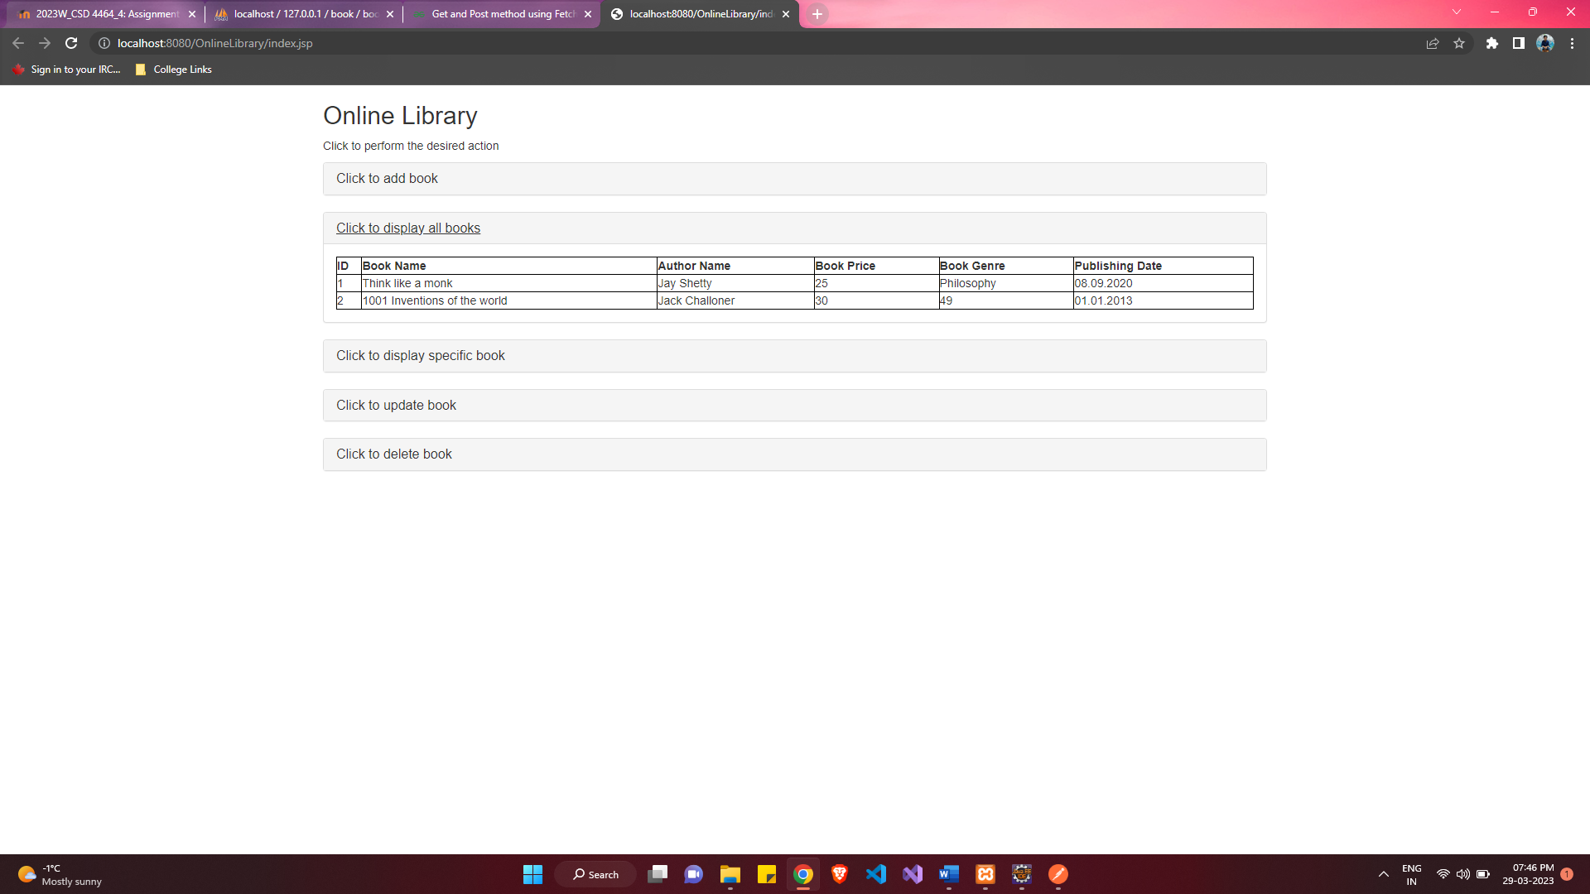

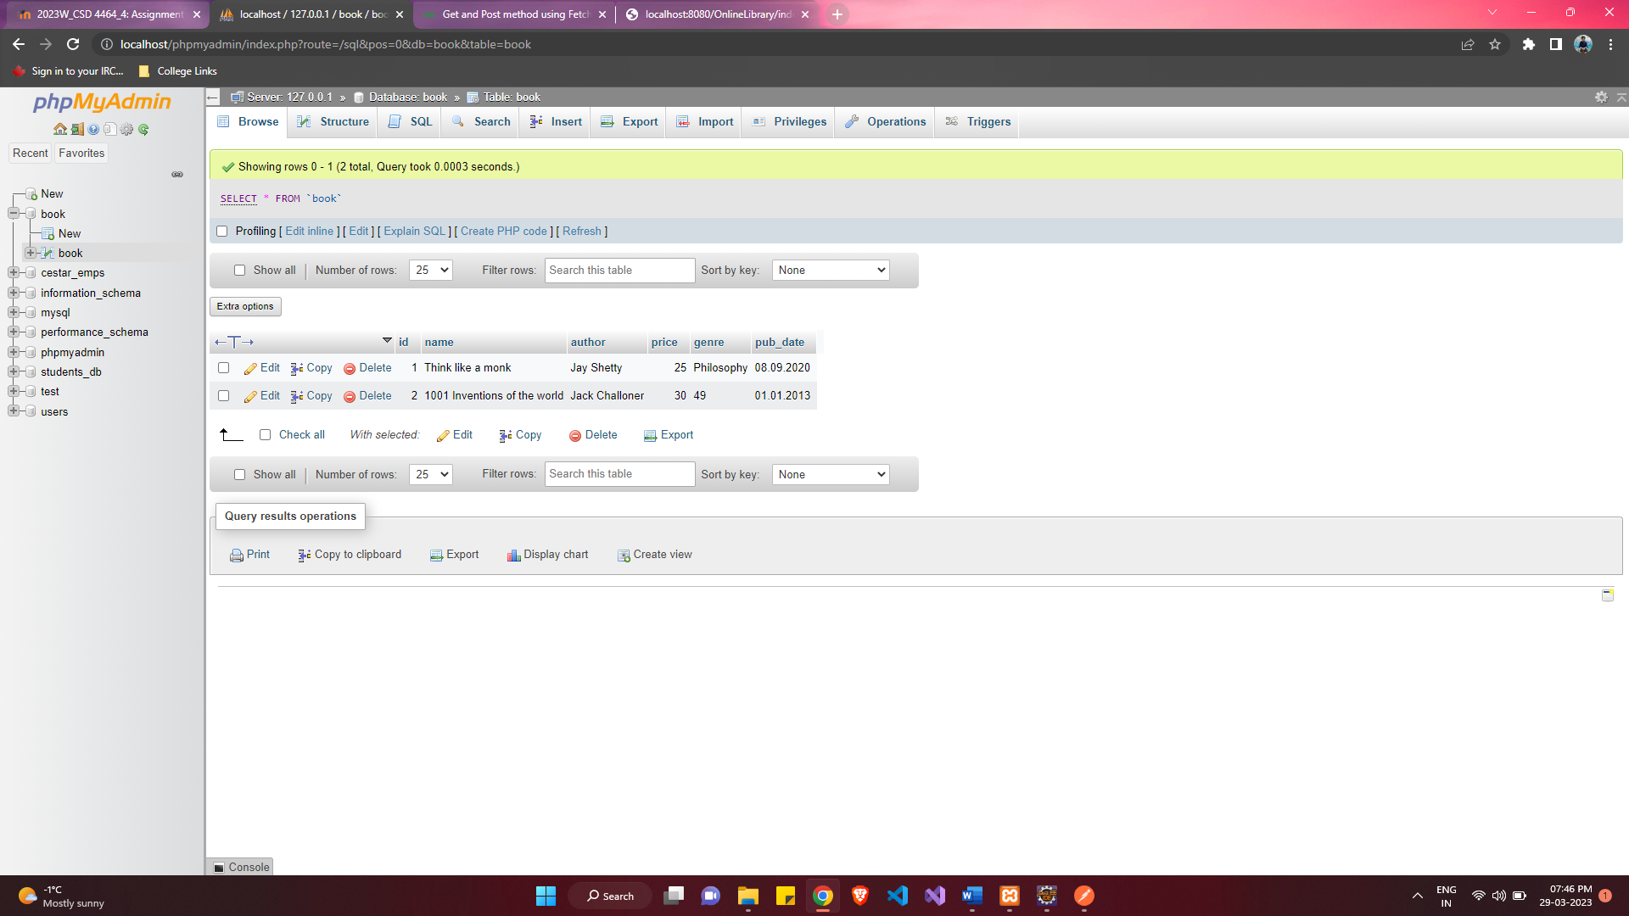

**Display Specific Book Method:**

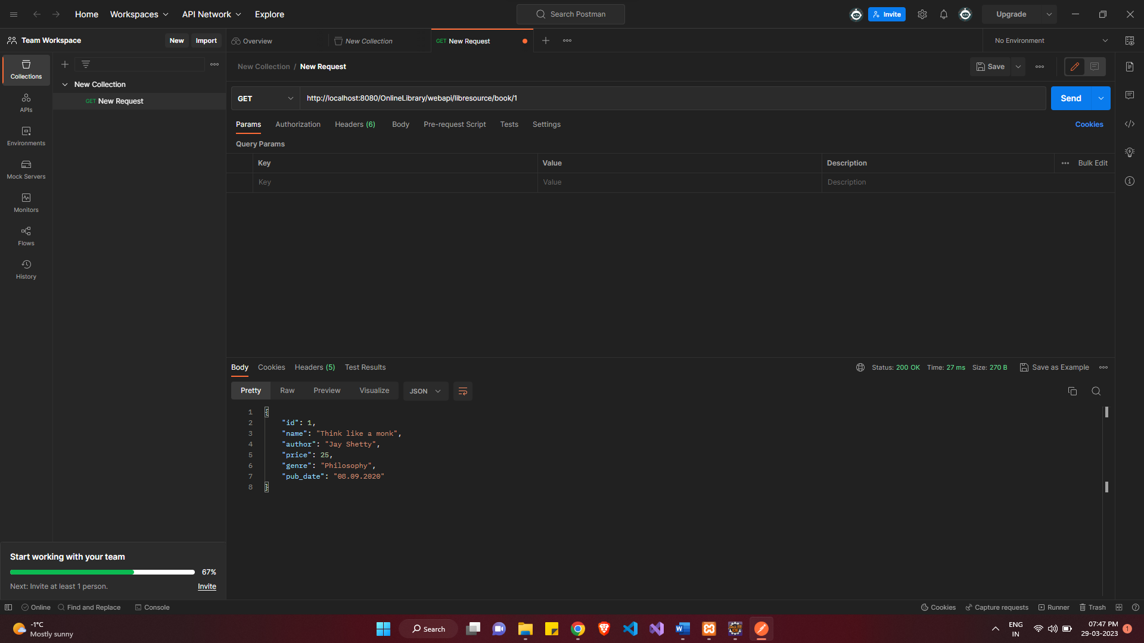

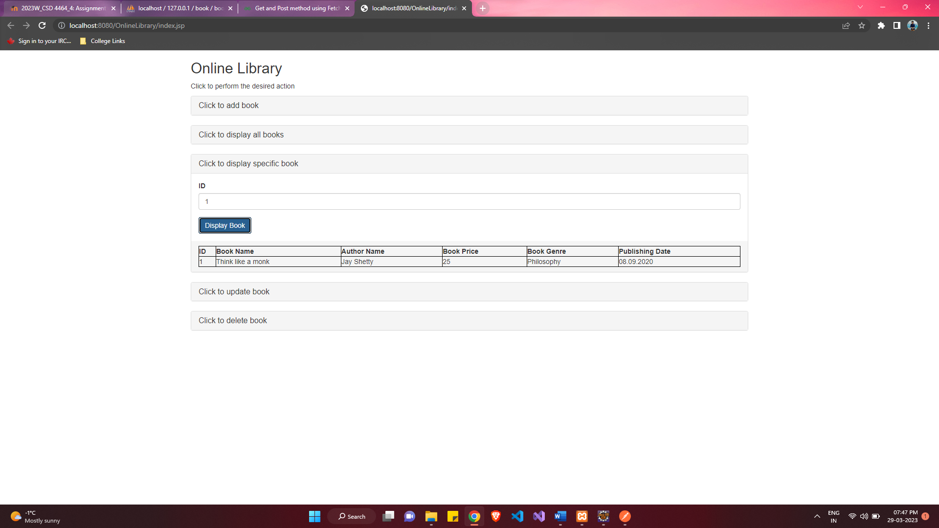

**Update Book Method:**

Before Update:

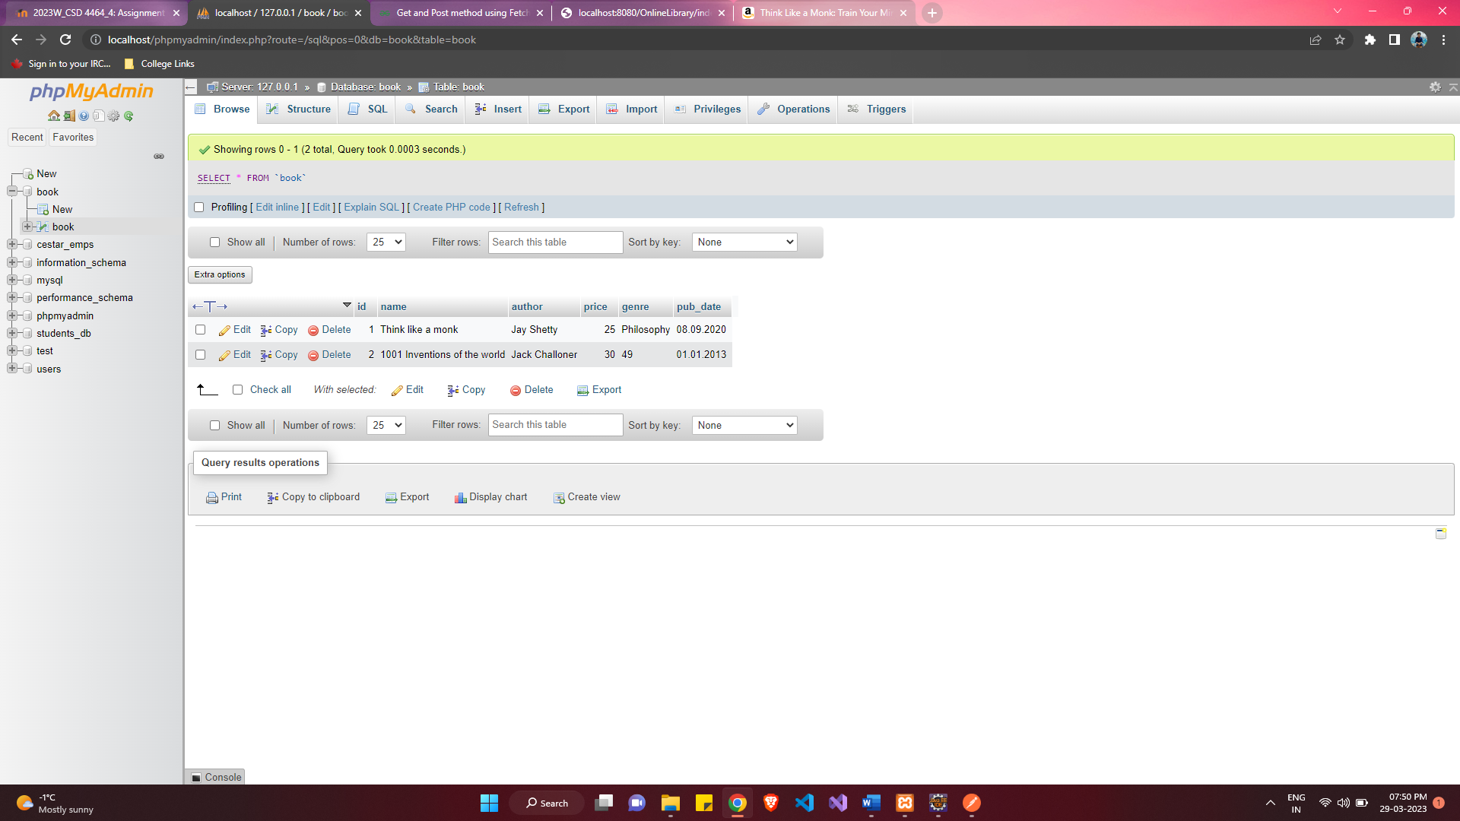

After Update:

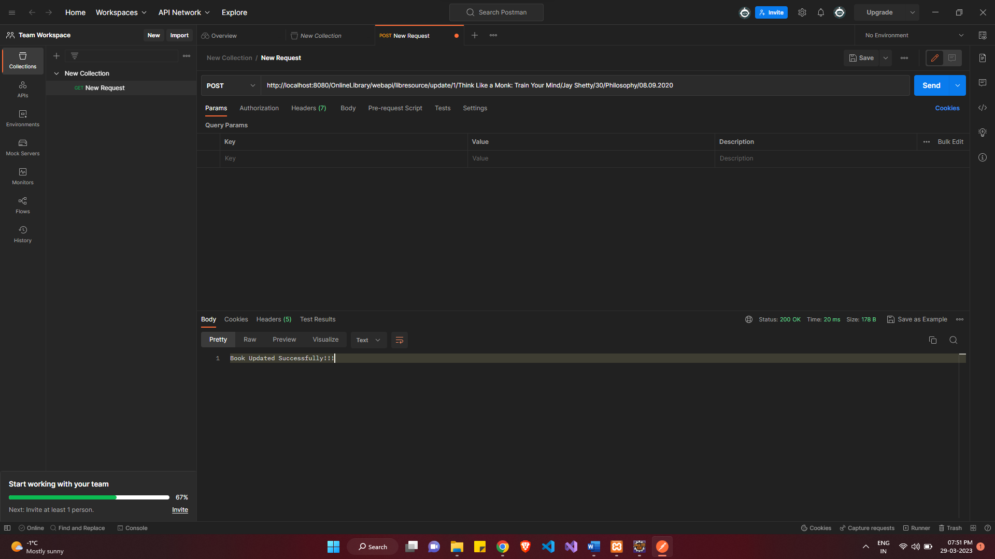

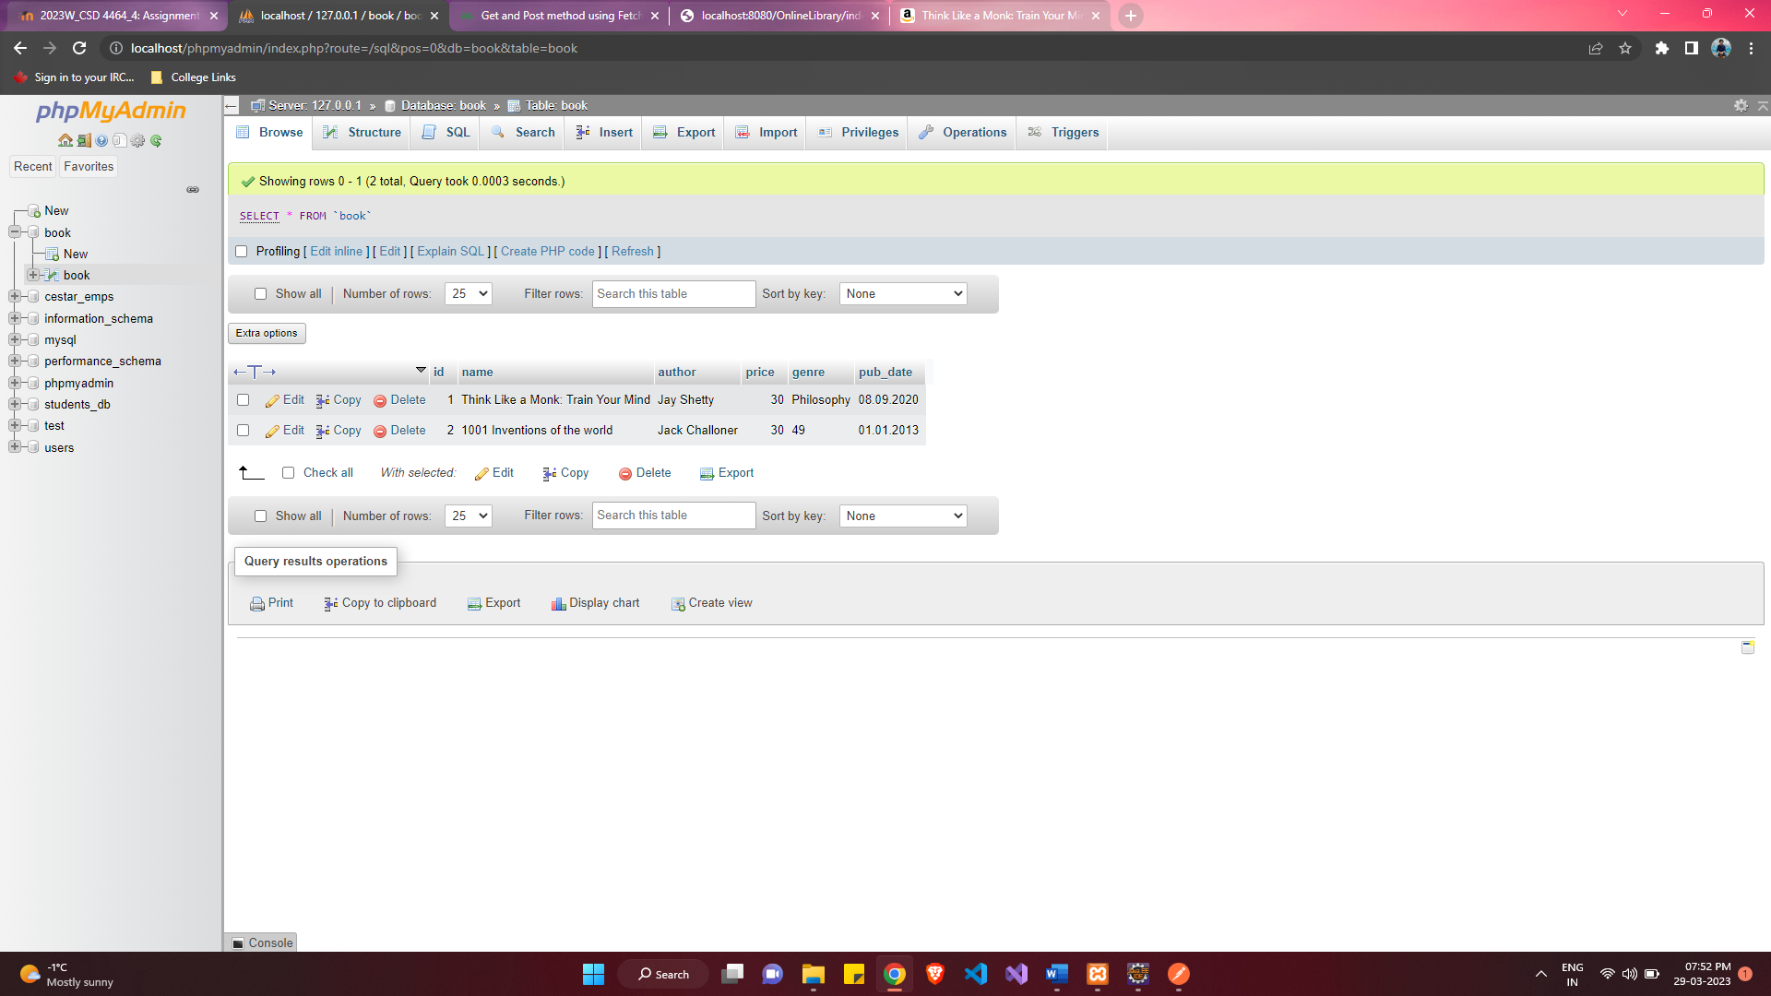

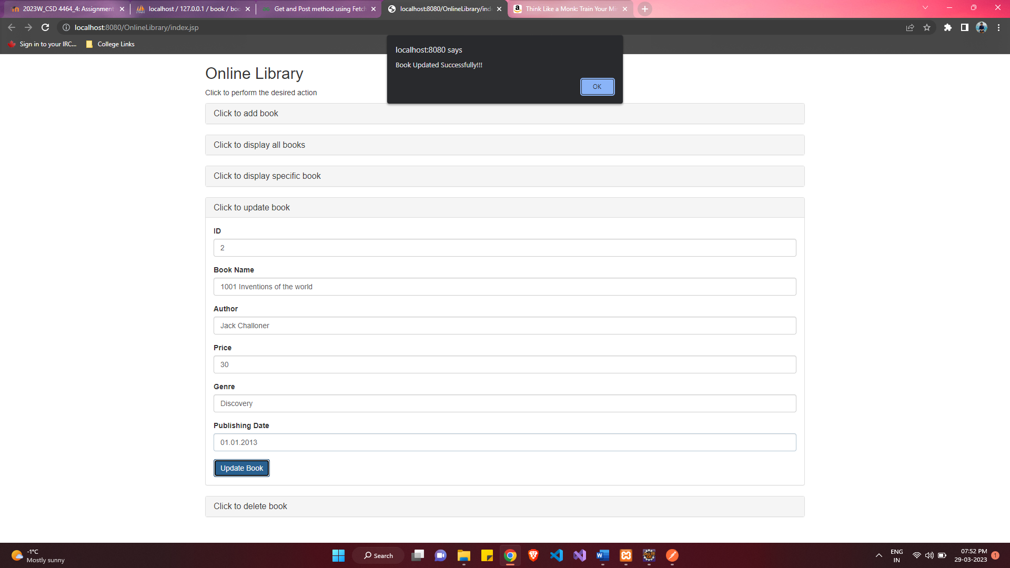

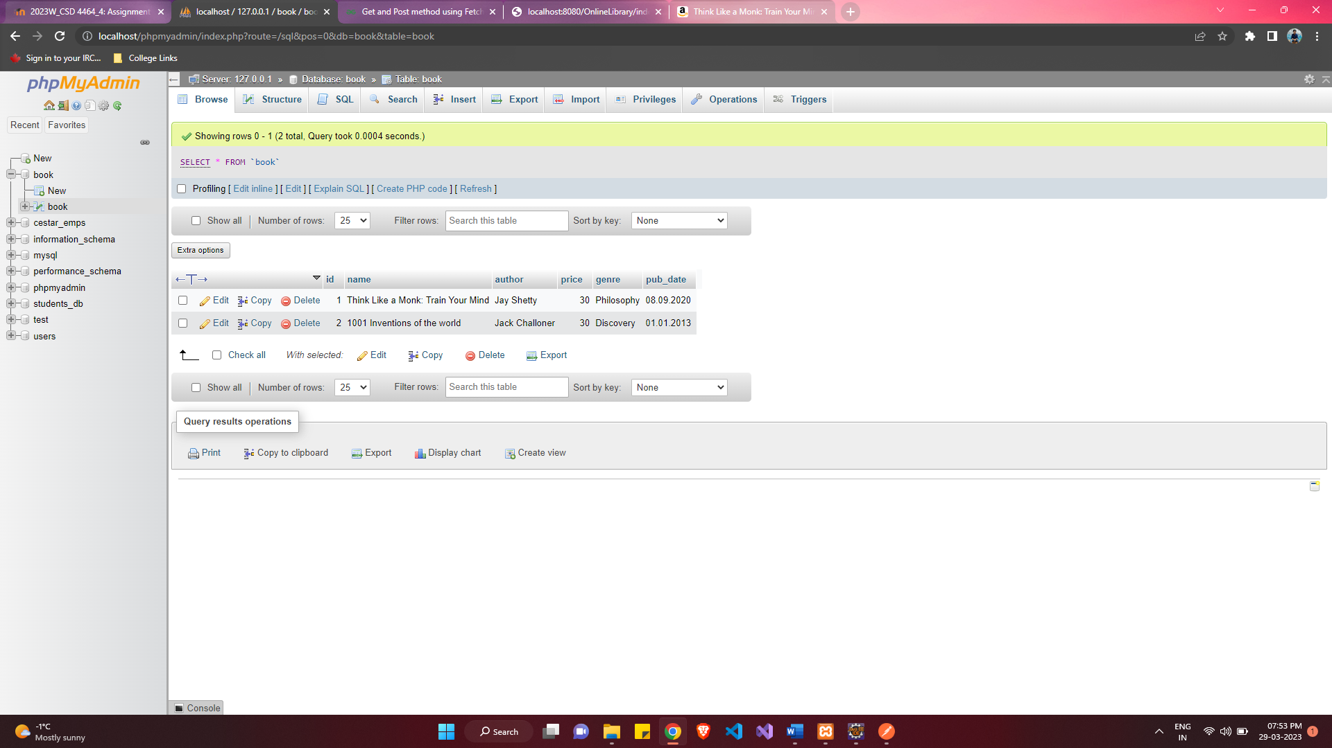

**Delete Book Method:**

Before Delete:

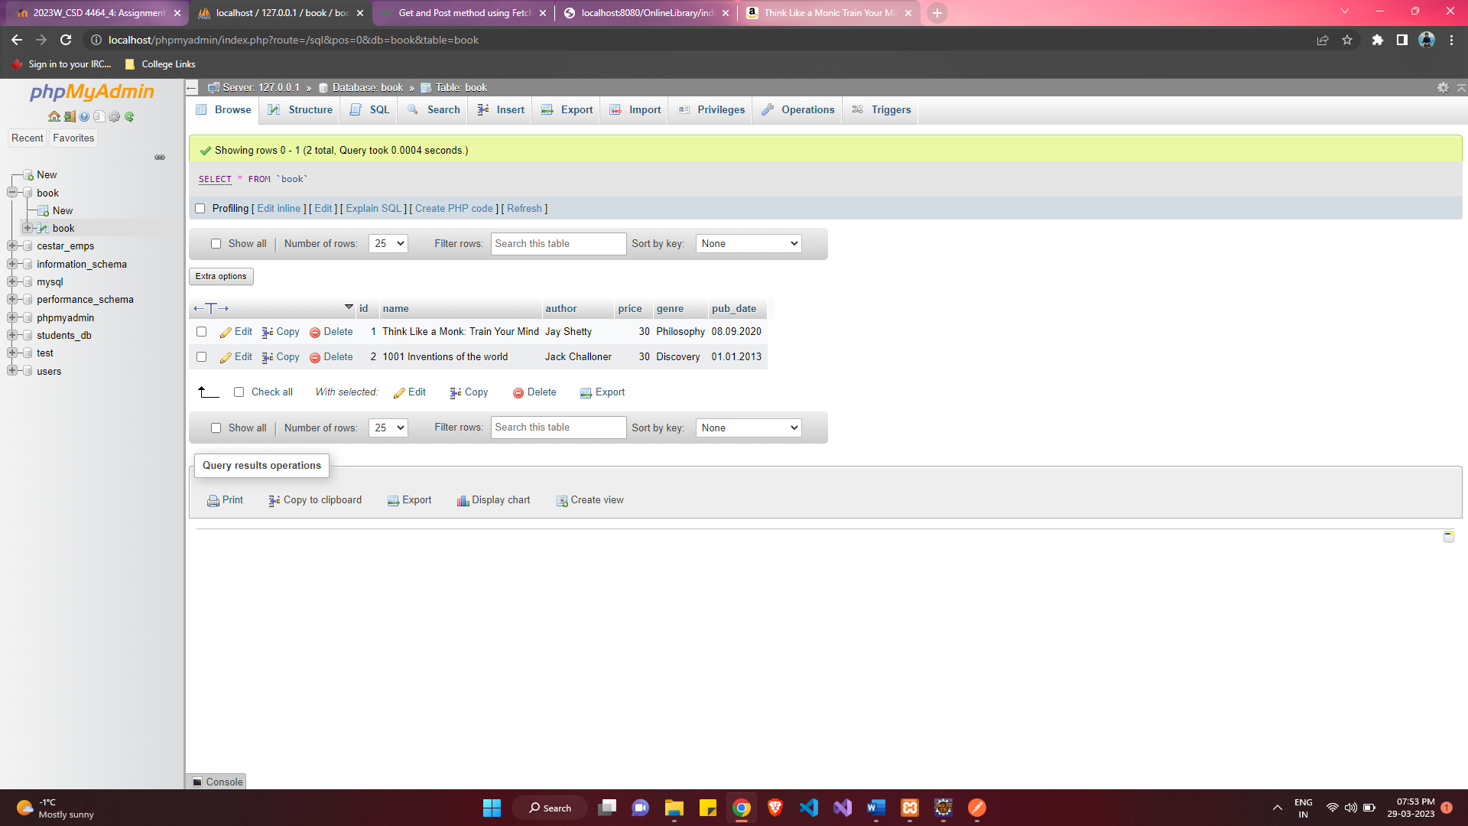

After Delete:

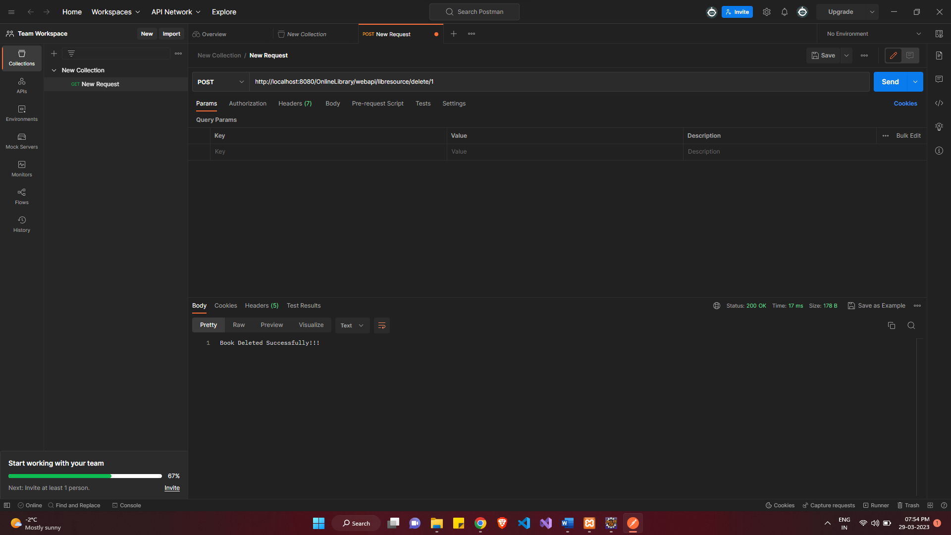

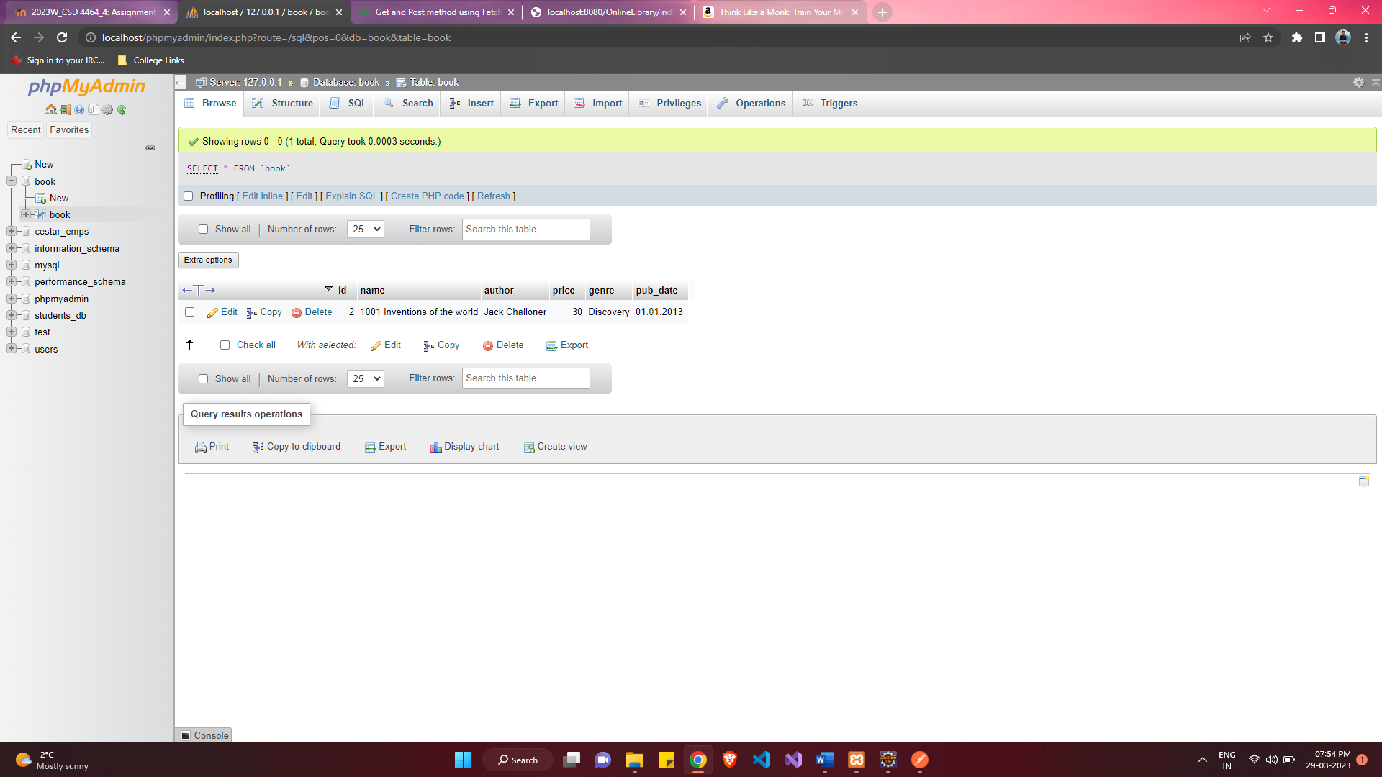

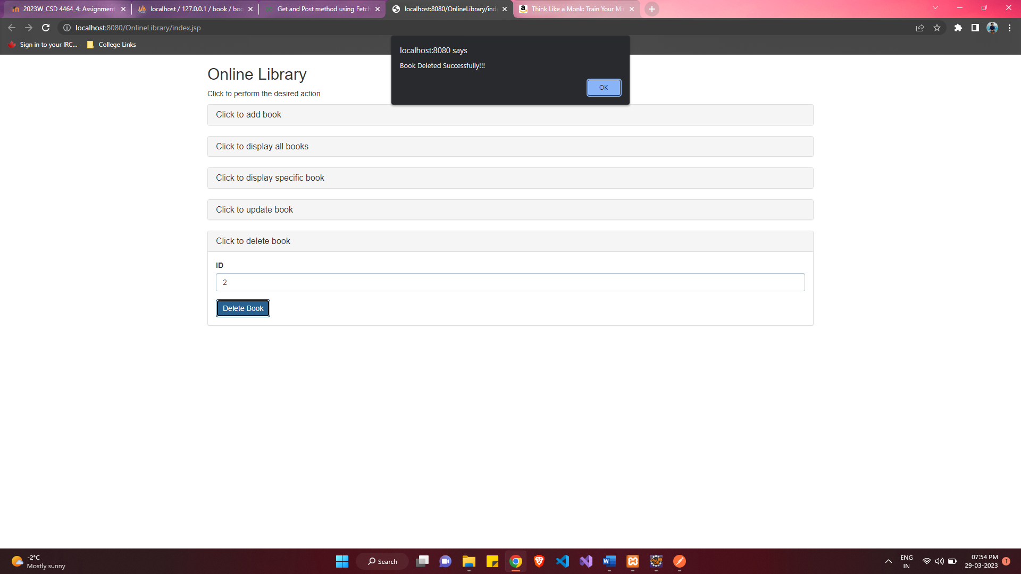

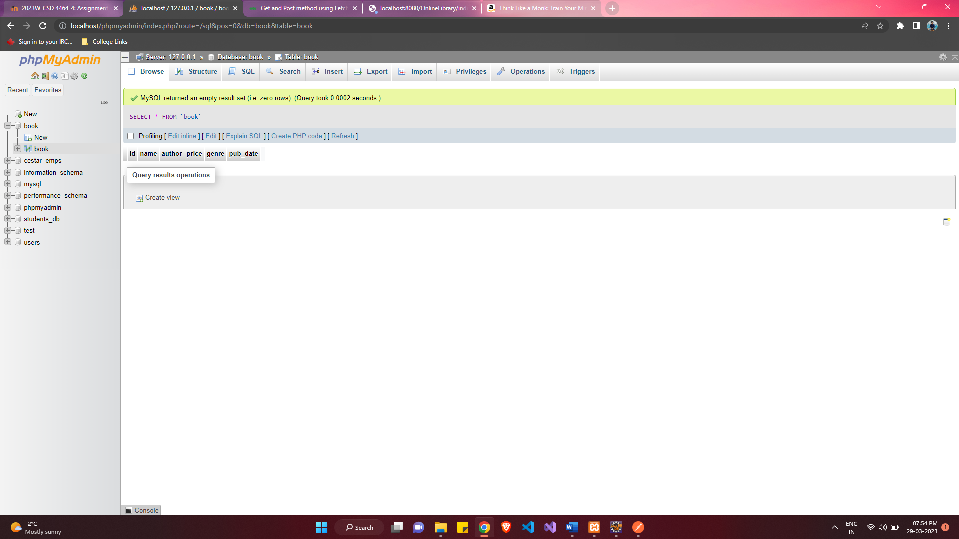

**Javadoc Generation:**

